BLOGNEST
AI-Powered Blog Management System
PROJECT DOCUMENTATION
TEAM LEADER
M. KAVIYA
(Code Executor)
TEAM MEMBER
MERLIN T. G.
(Voice Over & GitHub)
TEAM MEMBER
KAREN JOSSETTE. S.
(Documentation)
TEAM MEMBER
KIRUTHIKA. S.
(PPT & Presentation)

1. Introduction
BlogNest is a simple backend project developed for creating, storing, viewing and managing blog posts. The project uses Node.js and Express.js for the backend and MongoDB for storing user and blog data. It also includes AI features for generating blog content and summarizing existing blog content.

2. Project Objectives
- To create a simple platform for managing blogs.
- To provide user registration and login.
- To allow users to create and fetch blog posts.
- To use MongoDB for storing project data.
- To add AI support for blog generation and summarization.
- To test the APIs using Postman.

3. Technologies Used
- Node.js – Used to run the backend application.
- Express.js – Used to create the REST APIs and routes.
- MongoDB – Used as the database.
- Mongoose – Used to connect Node.js with MongoDB and create schemas.
- JWT – Used for user authentication.
- Postman – Used for API testing.
- Google Gemini AI – Used for AI blog generation and summarization.

4. Main Concepts
- User Registration – New users can create an account.
- User Login – Registered users can log in and receive an authentication token.
- Blog Creation – An authenticated user can create a new blog.
- Fetch Blogs – Blogs can be retrieved using the API.
- AI Blog Generation – A topic can be given to generate blog content using AI.
- Blog Summarization – Long blog content can be converted into a short summary.
- API Testing – Postman is used to check whether the APIs are working correctly.

5. Software Requirements
- Operating System: Windows 10/11 or similar.
- Node.js: Version 16 or above.
- npm: Used to install and manage packages.
- Visual Studio Code: Used for writing and running the project.
- MongoDB: Used to store project data.
- Postman: Used for testing APIs.

6. Hardware Requirements
- Processor: Intel i5 / AMD Ryzen 5 or equivalent.
- RAM: Minimum 8 GB.
- Storage: At least 1 GB free space for the project.

7. Project Architecture
The BlogNest backend follows a simple layered structure. A request is sent through an API such as GET or POST. Express.js handles the route, controllers process the request, Mongoose communicates with MongoDB, and the result is returned as JSON.
- API Layer – Receives requests from Postman or another frontend.
- Express Server – Handles routes and HTTP methods such as GET and POST.
- Authentication Middleware – Checks the login token before protected operations.
- Controller – Contains the main project logic.
- Model – Defines the data structure using Mongoose.
- MongoDB – Stores users and blog information.
- AI Service – Generates blog content and summaries.

8. Project Folder Structure
- server.js – Starts the backend server.
- models – Contains database schemas/models.
- controllers – Contains the main backend logic.
- routes – Contains API routes.
- middleware – Contains authentication-related code.

9. Project Setup
- Create a project folder and open it in Visual Studio Code.
- Open the Server folder in the VS Code terminal.
- Run: npm init -y
- Install the required packages such as Express, Mongoose and other project dependencies.
- Create server.js and the required folders such as models, controllers and routes.
- Connect the project with MongoDB.
- Start the server using: npm start

10. Database Configuration
MongoDB is used as the main database. Mongoose is used to create schemas and communicate with MongoDB. The project stores user details and blog details in the database.
- User data includes name, email, password and role.
- Blog data includes title, content, category and author information.
- Passwords are stored securely using password hashing.

11. API Testing
After starting the backend server, the APIs are tested using Postman. The screenshots below show the API requests and responses obtained from the project.
Figure 1: Starting the backend server and API testing section

12. User Registration and Login
User registration is used to create a new account. After registration, the user can log in using the registered email and password. The login response provides an authentication token that can be used for protected APIs.
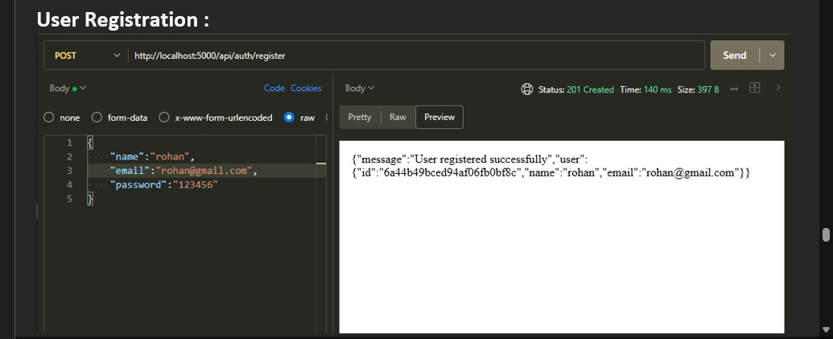
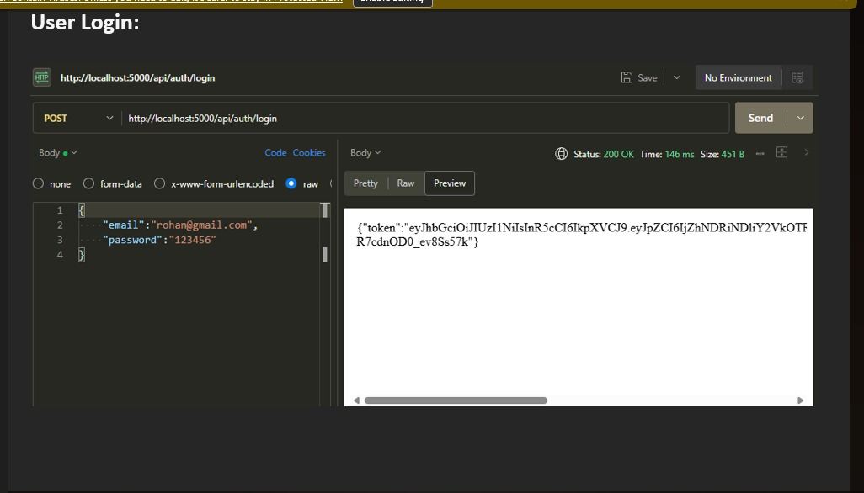
Figure 2: User Registration and User Login API

13. Create Blog
The Create Blog API is used to add a new blog. The request contains details such as the title, content and category. The API returns the created blog information when the request is successful.
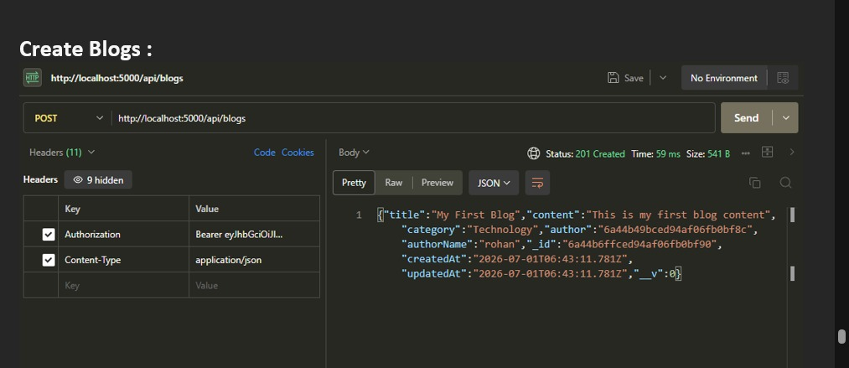
Figure 3: Create Blog API

14. Fetch Blogs
The Fetch Blogs API uses the GET method to retrieve the available blogs from the database.
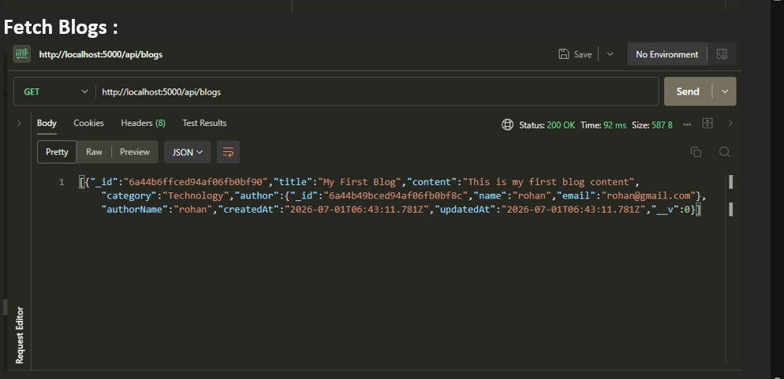
Figure 4: Fetch Blogs API

15. Generate AI Blogs
The Generate AI Blog API accepts a topic and category. The AI service processes the request and returns generated blog content. This feature helps to create a basic blog draft quickly.
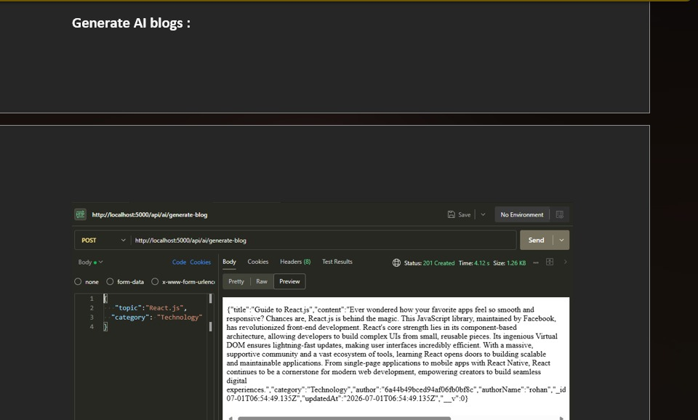
Figure 5: Generate AI Blog API Response

16. Summarize Blogs
The Summarize Blog API accepts blog content and returns a shorter summary. This is useful when the original content is long and the user needs a quick overview.
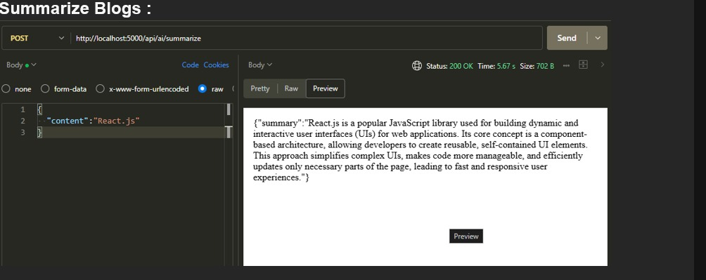
Figure 6: Summarize Blog API Response

17. Conclusion
BlogNest is a simple backend project that combines normal blog management with AI features. The project demonstrates user authentication, API creation, MongoDB database connection, blog creation and retrieval, AI-based blog generation and blog summarization. The APIs were tested using Postman and the responses were verified successfully.

18. Future Enhancement
- A complete frontend can be added for easier user interaction.
- More user roles and permissions can be added.
- Blog editing and deleting features can be extended.
- More AI-based features can be added.
- The project can be deployed online for real-world use.

